Guide

Use production.
We are going to use a suitelet that will run every hour, and will create one file for each of the custom record of NSPOS Donated Goods Pricing. We will only have 1 NSPOS Donated Goods Pricing with 1 item class.
There is not going to be multiple NSPOS Donated Goods Pricing with same item class.

Get to list of NSPOS Donated Goods Pricing Custom record
From them get:
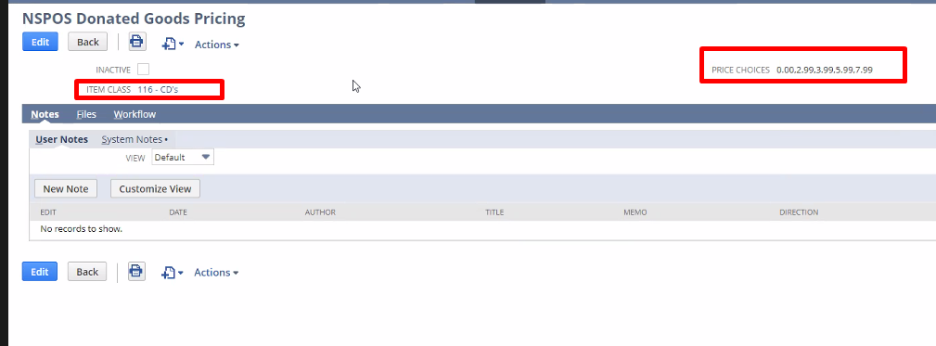
Item class (this will be hidden on NSPOS Donated Goods Pricing record, and can not be modifiable once it’s added) -> get the record for it -> get NSPOS Parent Class Item ID -> This will be the file name.
Price choices -> this will be the file content.

Then create the file on: File cabinet -> NSPOS -> File System -> RAPOS -> Printing.

If they inactivate the NSPOS Donated Goods Pricing record -> delete the file.

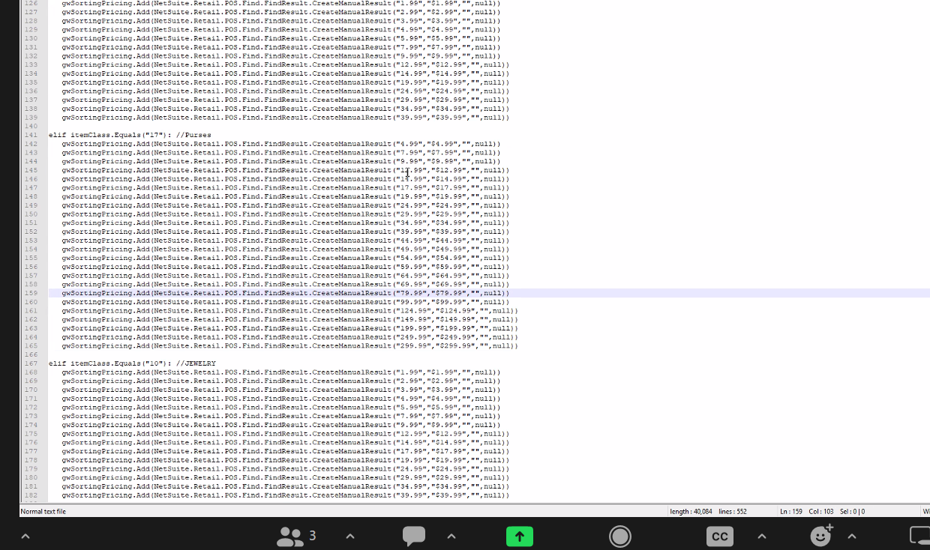

They can not modify Parent class item ID.

